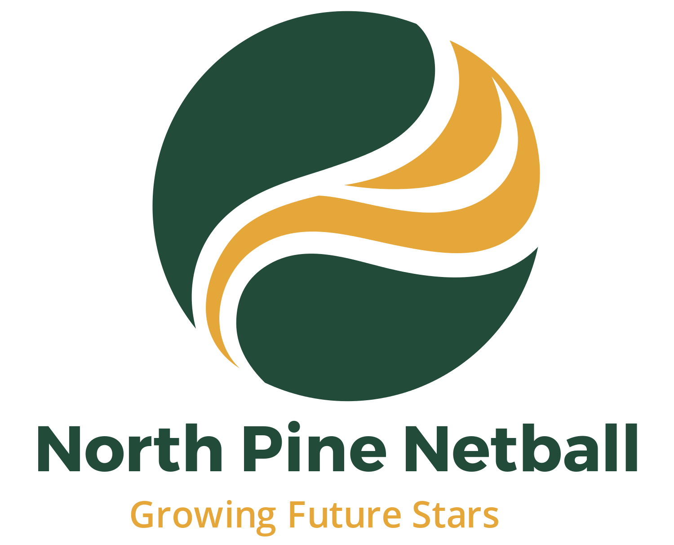
Codes of Conduct

Coach
In addition to Netball Queensland’s General Code of Behaviour, you must meet the following requirements with regard to your conduct during any activity held by or under the auspices of Netball Queensland and persons identified in the Member Protection Policy Clause 3 in your role as a Coach.

- Operate within the rules and spirit of netball, promoting fair play over winning at any cost.
- Encourage and support opportunities for people to learn appropriate behaviour and skills.
- Support opportunities for participation in all aspects of the sport.
- Treat each person as an individual.
- Display control and courtesy to all involved with the sport
- Respect the rights and worth of every person regardless of their gender, ability, cultural background or religion.
- Respect the decisions of umpires, officials, coaches and administrators in the conduct of the sport.
- Wherever practical, avoid unaccompanied and unobserved one-on-one activity (when in a supervisory capacity or where a power imbalance will exist) with people less than the age of 18 years.
- Adopt appropriate and responsible behaviour in all interactions.
- Adopt responsible behaviour in relation to alcohol and other drugs.
- Act with integrity and objectivity, and accept responsibility for your decisions and actions.
- Ensure your decisions and actions contribute to a safe environment.
- Ensure your decisions and actions contribute to a harassment free environment.
- Do not tolerate harmful or abusive behaviour.
- Place the safety and welfare of the athletes above all else.
- Help each person (athlete, umpire etc.) reach their potential - respect the talent, developmental stage and goals of each person and compliment and encourage with positive and supportive feedback.
- Any physical contact with a person should be appropriate to the situation and necessary for the person’s skill development.
- Be honest and do not allow your qualifications to be misrepresented.
- Failure to comply with the code of behaviour could result in termination of Coach from North Pine Sports Club Inc.

Junior Player
In addition to Netball Queensland’s General Code of Behaviour, you must meet the following requirements with regard to your conduct during any activity held by or under the auspices of Netball Queensland and persons identified in the Member Protection Policy Clause 3 in your role as a Junior Player.

- Participate because you enjoy it, not just to please parents and coaches.
- Play by the rules
- Know the rules.
- Participate fairly and safely.
- Abide by decisions, without argument or bad temper
- Captains have the right to approach an umpire during an interval or after the game for clarification of any rule
- Approach the umpire in a courteous and polite way.
- Co-operate with your coach, and other players
- Verbal abuse of officials or other players, deliberately fouling or provoking an opponent and throwing/ damaging equipment is not acceptable or permitted

- Treat all players as you would like to be treated
- Ensure that at all times your behaviour is fair
- Be a patient and enthusiastic supporter of fellow players.
- Applaud all good play, by your own team and opponents.
- Be a responsible team member
- Always be on time
- Encourage and assist all players
- Attend all training sessions
- Ensure you always bring the appropriate uniform and equipment to training and/ or matches.
- Do not engage in practices that affect sporting performance (alcohol, tobacco and drug use).
- Respect and acknowledge the contribution of those who create the opportunity for you to play
- Volunteers (scorers, coaches, timekeepers, administrators and umpires).

Senior Player
In addition to Netball Queensland’s General Code of Behaviour, you must meet the following requirements with regard to your conduct during any activity held by or under the auspices of Netball Queensland and persons identified in the Member Protection Policy Clause 3 in your role as a Senior Player.

- Respect the rights, dignity and worth of fellow players, coaches, officials and spectators.
- Refrain from conduct which could be regarded as sexual or other Harassment.
- Respect the talent, potential and development of fellow players and competitors.
- Care and respect the uniform and equipment provided to you.
- Be frank and honest with your coach concerning illness and injury and your ability to train and play fully.
- Conduct yourself in a responsible manner relating to language, temper and punctuality.
- Maintain a high standard of personal behaviour at all times.
- Abide by the rules and respect the decision of the umpires. Be courteous and use the correct process when seeking a rule clarification.
- Be honest in your attitude and preparation to training. Work equally hard for yourself and your team.
- Co-operate with coaches and staff in relation to programs that adequately prepare you for competition.
- Do not engage in practices that affect sporting performance (alcohol, tobacco and drug use).

Umpires
In addition to Netball Queensland’s General Code of Behaviour, you must meet the following requirements with regard to your conduct during any activity held by or under the auspices of Netball Queensland and persons identified in the Member Protection Policy Clause 3 in your role as an Umpire.

- Umpire in accordance with the Official Rules of the Game.
- Treat all players, coaches, match officials and other umpires with respect.
- Place the safety and welfare of the players above all else.
- Ensure the court and its surrounds are compliant with the rules.
- Take appropriate action to manage dangerous play.
- Maintain a high standard of personal behaviour at all tes.
- Be a positive role model through behaviour and personal appearance projecting a favourable image of netball and umpiring at all times.
- Be courteous, respectful and open to discussion and interaction.
- Maintain or improve your current performance level and seek continual improvement.

Parents, Guardians and Spectators
In addition to Netball Queensland’s General Code of Behaviour, you must meet the following requirements with regard to your conduct during any activity held by or under the auspices of Netball Queensland and persons identified in the Member Protection Policy Clause 3 in your role as a Parent/Guardian.

- If your child is interested, encourage them to participate in the appropriate netball activity. However, if your child is not willing to participate, do not force him or her. Remember, children are involved in organised activity for their enjoyment, not yours.
- Focus upon your child's efforts and performance rather than the overall outcome of the event. This assists your child in setting realistic goals related to his/ her ability by reducing the emphasis on winning.
- Teach your child that an honest effort is as important as victory, so that the result of each game is accepted without undue disappointment.
- Encourage your child to play always according to the rules.
- Never ridicule or yell at a child for making a mistake or losing a game.
- Remember that children learn best from example. Applaud good play by all players.
- If you disagree with an umpire or coach raise the issue through the appropriate channels rather than question their judgment and honesty in public.
- Support all efforts to remove verbal and physical abuse.
- Recognise and respect the value and importance of volunteer administrators, coaches and umpires. They give up their time and resources to provide recreational activities for players and deserve your support.
- Be a model of good sports behaviour for children to copy.
- Be courteous in communication with administrators, coaches, players and umpires. Teach children to do likewise.
- Support the use of age appropriate development activities and modified rules.

Team Manager
As a person required to comply with this Policy, you must meet the following requirements with regard to your conduct during any activity held or sanctioned by Netball Queensland and persons identified in the Member Protection Policy Clause 3.

- Treat all persons with respect and courtesy and have proper regard for their dignity, rights and obligations.
- Be ethical, fair, considerate and honest in all dealings with others.
- Make a commitment to providing quality service.
- Operate within the rules and spirit of the sport including national and state guidelines, constitution and policies which govern Netball Queensland and persons identified in the Member Protection Policy Clause 3.
- Do not use your involvement with netball to promote your own beliefs, behaviours or practices where these are inconsistent with those of Netball Queensland and persons identified in the Member Protection Policy Clause 3.
- Demonstrate a high degree of individual responsibility especially when dealing with persons less than 18 years of age, as your words and actions are an example.
- Always place the safety and welfare of children above other considerations.
- Avoid unaccompanied and unobserved activities with persons less than 18 years of age, wherever possible.
- Comply with all relevant Australian laws (Federal and State), particularly anti-discrimination and child protection laws
- Refrain from any behaviour that may bring Netball Queensland and persons identified in the Member Protection Policy Clause 3 into disrepute.
- Provide a safe environment for the conduct of the activity.
- Show concern and caution towards others who may be sick or injured.
- Be a positive role model.
- Be responsible and accountable for your conduct.
- Abide by the relevant Netball Queensland role-specific codes of behaviour and understand the repercussions if you breach, or are aware of any breaches of this Code of Behaviour.

Declaration

I, ___________________________________________________________________________________________
have read and understood the code of conduct and will abide by all that apply to me as a member of North Pine Netball Club.
Signature: ________________________________________________
Date: ________________________________________________

If under 18 years of age, parent/guardian:
Signature: ________________________________________________
Date: ________________________________________________

